Egg Drop Project Lab Report

Brian Cullinan
Becca Reuter

12/4/01

Purpose:

The purpose of this project it to create a container that will safely protect an egg being dropped from 7.3 meters up. The question is “can it be done”. All of my very reliable resources told me that it is in fact possible. They have mass amounts of ideas. Some work some don’t. Another question needed is “Where to place the egg, how to set it up”. From a reliable source, the egg should be placed small end down at the top of the container. I will follow this instruction. Another idea would be to make sure the container doesn’t turn. So therefore I decided to make our container the same shape of the egg. Then, when it falls, the container will not turn over because the bottom is larger then the top.

Materials:

1 Egg
1 Balloon
Glue
Paper
Water
Paint Brush
Cotton
Packing Materials
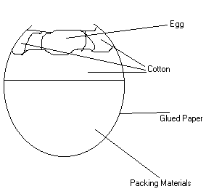

Procedure:

Blow up a balloon. Make a mixture of glue and water. Cut up pieces of paper about 2” by 2”. Paint each piece of paper. Either use a brush or just dip it in the mixture. Then place it on the balloon. Make sure it is all covered and once you have the first layer on wait for about ten minutes of it to dry. You can also use a hair dryer. After you are done for the day check it the next day to see if it is hard enough. If it is, pop the balloon and take it out. Now you add cotton, or packing materials. Put the egg in a bag then place it inside the container. Then you can tape the top or put more cotton in the top.
The container should not turn or spin around while falling. Because of the shape it falls strait. To ensure this you can also add fins to the container. The speed or momentum should not be very great. Because the container is made up of paper and cotton it is very light. When it hits the ground the bottom or sides might crush in, but you can easily pop it back out again.

Outcome:

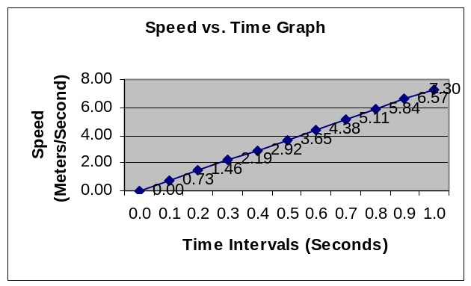The first time we dropped, my egg broke. It was very sad. It splattered. But then I made some revisions and I would have worked. The time it took to fall was .99 sec. The average speed was 3.61 meters/second. Here is the table of data.
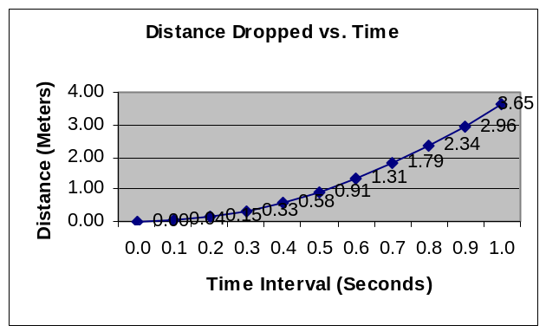

Discussion/Conclusions:

I have learned that and egg in a crate can survive the fall from 7.3 meters up. The shape of the crate does affect the way it falls. A suggestion might be have it fall a certain way by putting fins on it. I learned a lot about physics doing this. I hope my partner feels the same way.

Resources:

http://www.engin.swarthmore.edu/org/asme/egg01/egg01.html

http://www.mse.arizona.edu/faculty/birnie/EngrsWk/EggDrop.htm

http://www.asme.org/sections/eastern_north_carolina/eggdrop/2000/auxillary/EGGDROP1.html

